

***Reachout America***

***Helping Special Kids Across America***

**6071 Queens River Drive Mableton GA. 30126**

**Date: ________**

**To Whom It May Concern,**

**I would like to grant the ability for _______________to complete court-ordered community service hours in the _________________________ area through our national nonprofit foundation.**

**As the CEO of Reachout America – a nonprofit organization that helps sick and special needs kids across America, our organization offers a unique alternative to jail and court time for non-violent offenders.  In lieu of serving time behind bars, our organization offers a simple and meaningful way for offenders to work off their court-ordered community service hours, while simultaneously enabling them to help a special needs child or specialty camp in their area.**

**While offenders participating in our program do not ever have direct contact with the children we help and do not physically work at or on any of the camp locations, the community service hours they complete help to raise donations to send the children to those camps.**

**Our program has been embraced, welcomed, and promoted across the country by Probation Officers, Judges, and District Attorneys because they understand how difficult it is to find a place for the non-violent offenders to complete the hours while also trying to hold down a job and/or attend school. ________________ -- an individual in your system requested to perform community service with our foundation and has been accepted into our program.**

**Sincerely,**

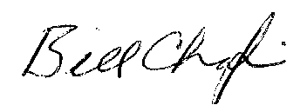

**Bill Chafin - Director**

**Reachout America**

**EIN 02-0728707**

**Phone 1.877.238.8544**

**ReachoutAmerica.com**